New Features:

1. Tagging post allows people to tag their posts using one or multiple keywords.

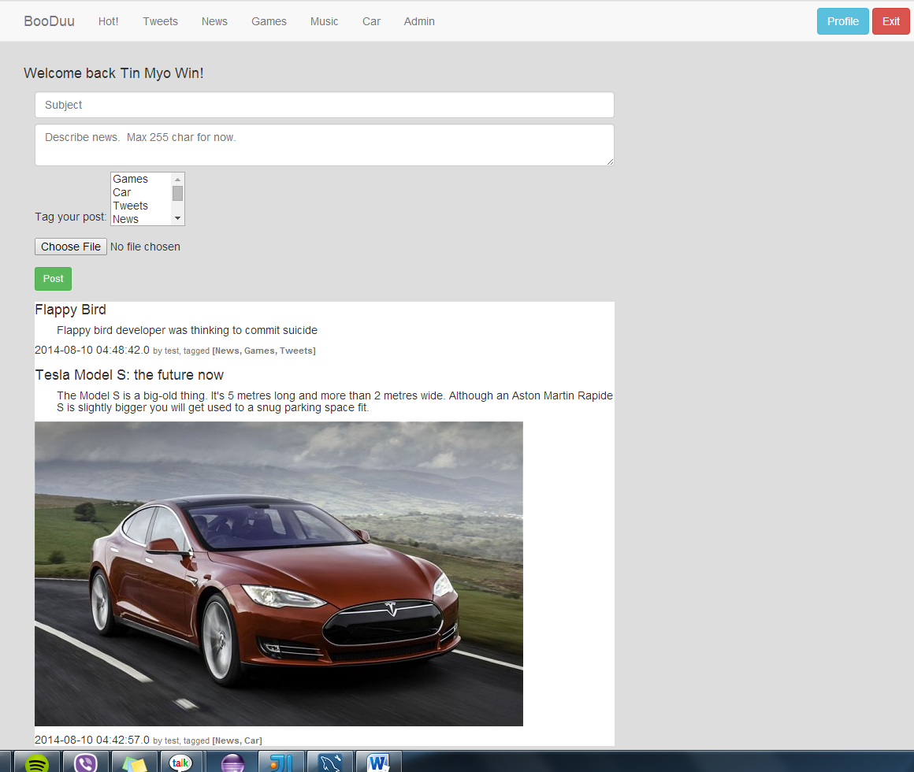

1. Session handling allows user to keep session and check profile page

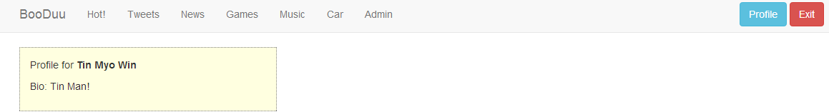

1. the tagged posts will be appeared on respective Labelled menu item. For example, if a user tags a post as ‘Car’, then the post will be appeared in ‘Car’ menu

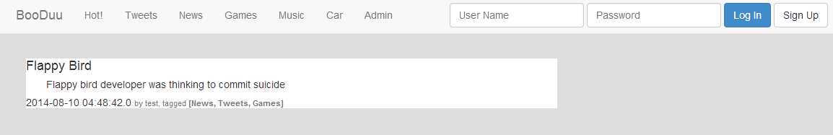

When use clicks on Tweets session

When use clicks on Car session

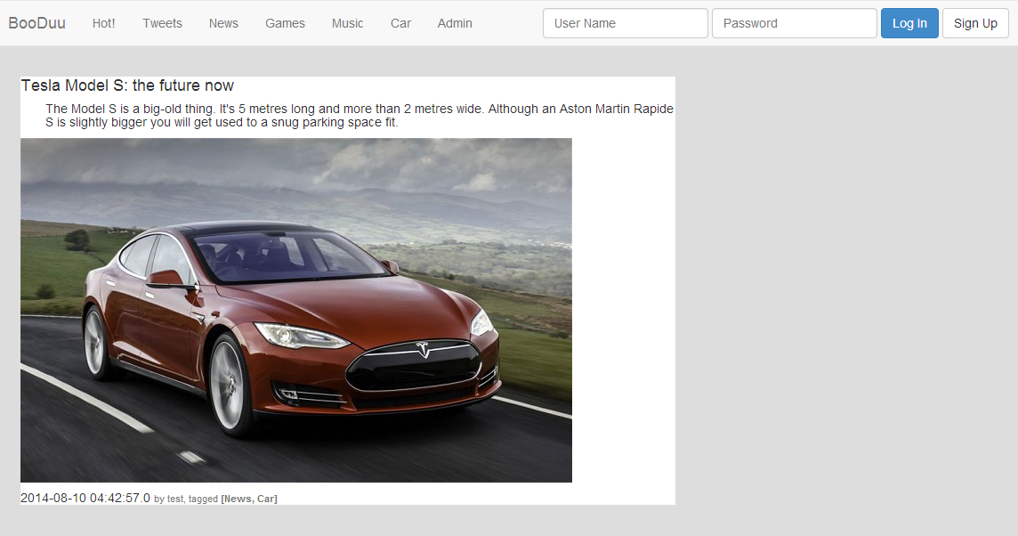

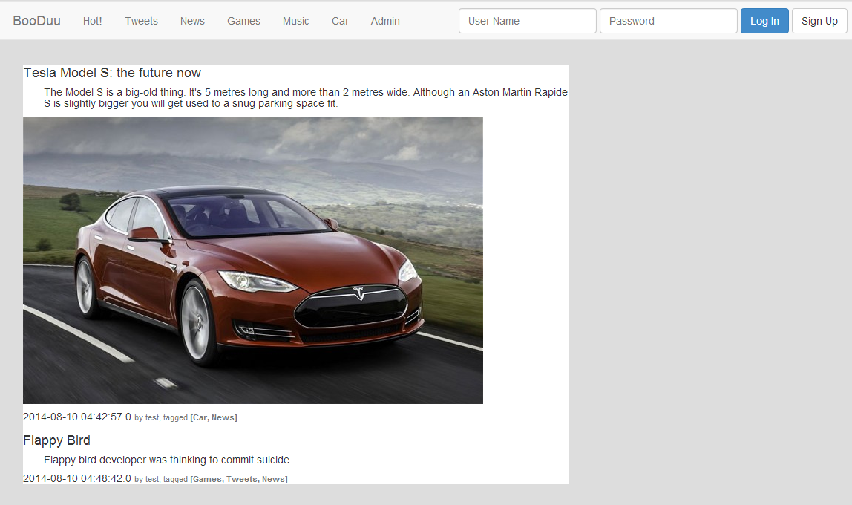

When use clicks on News session